Nama : Tika Pratiwi

NIM : L200170046

Kelas : C

TUGAS

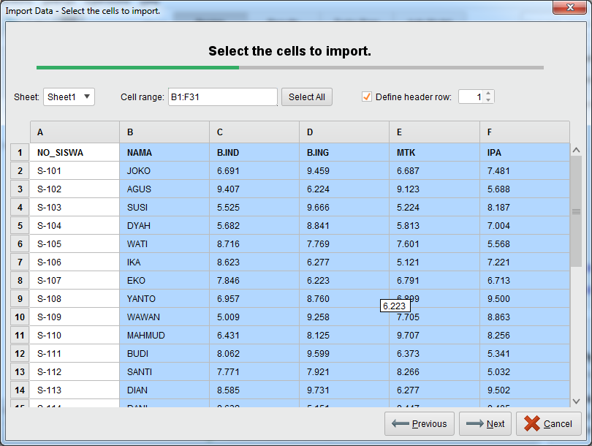

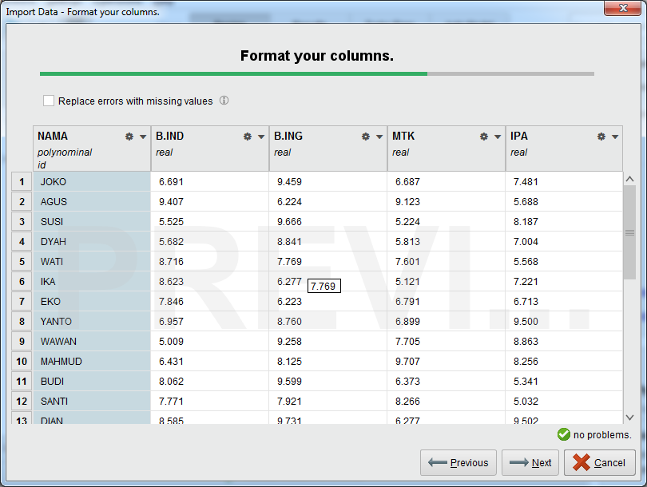

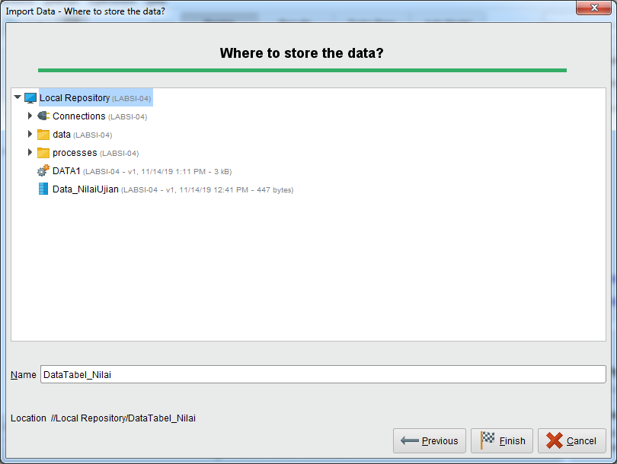

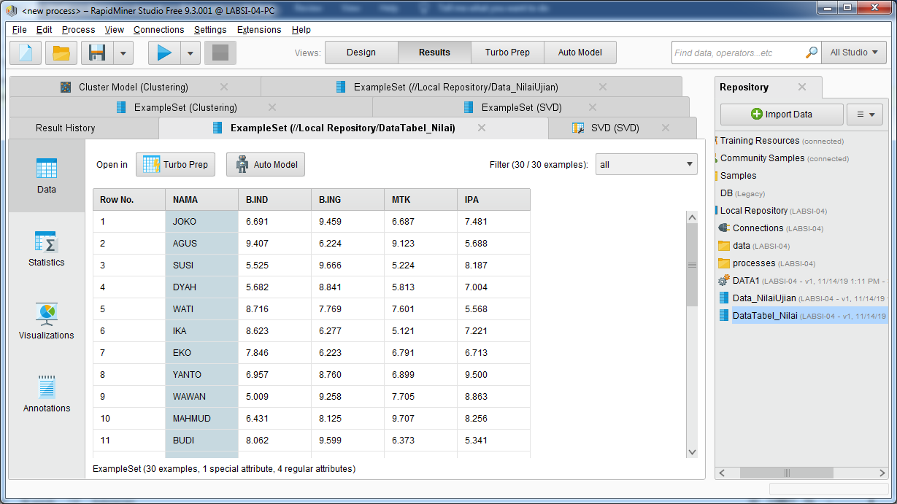

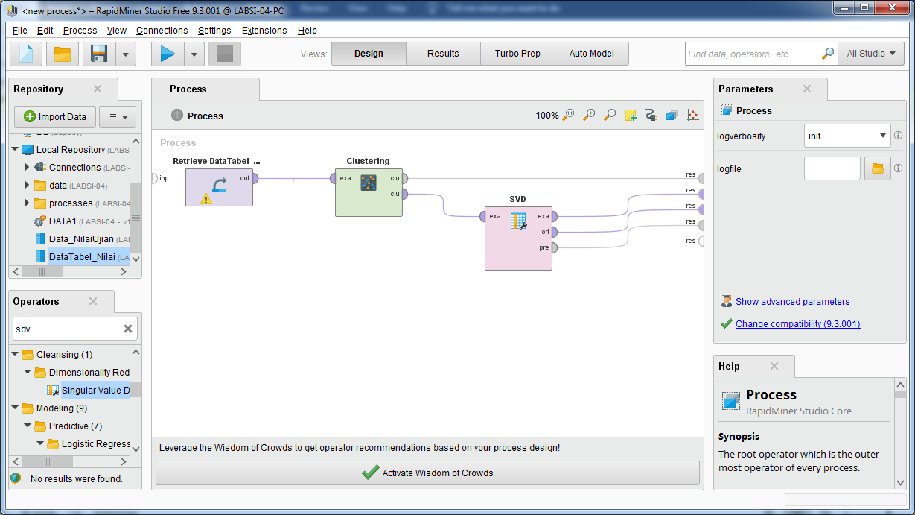

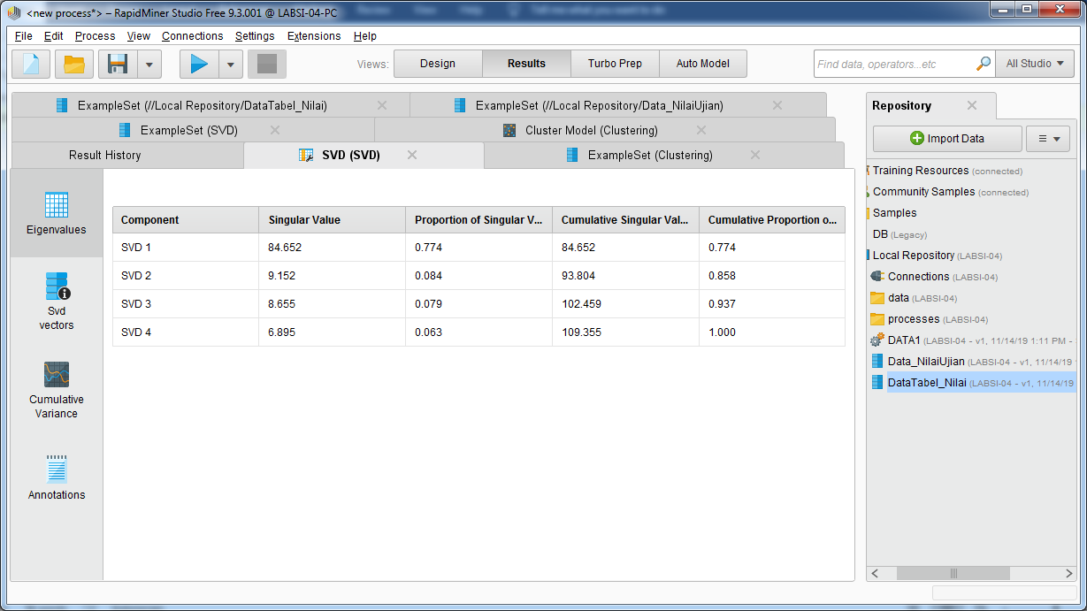

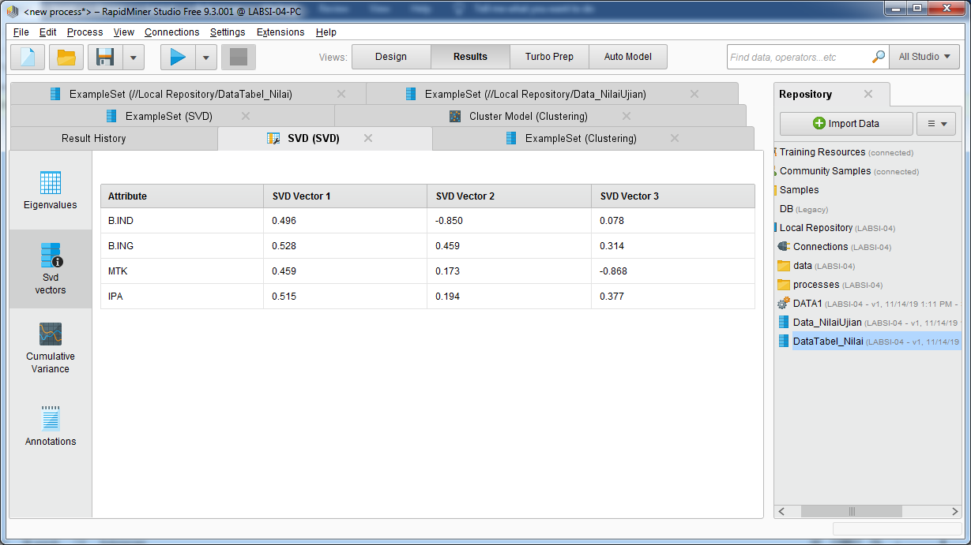

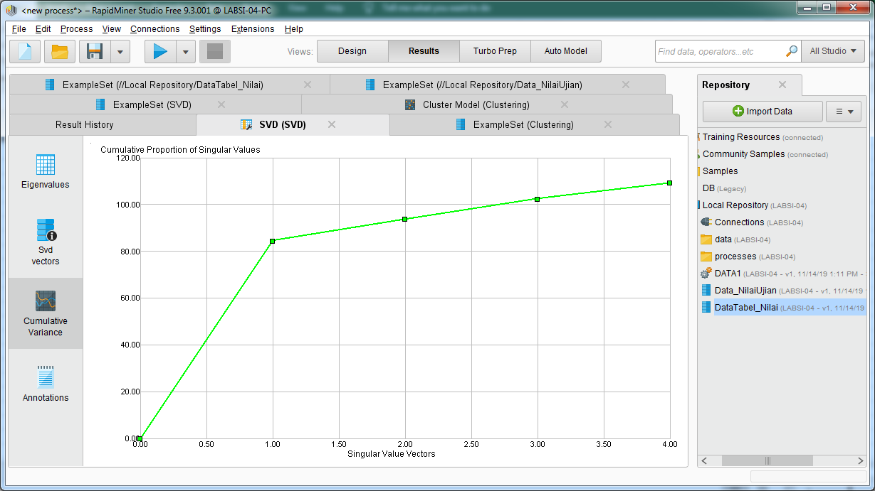

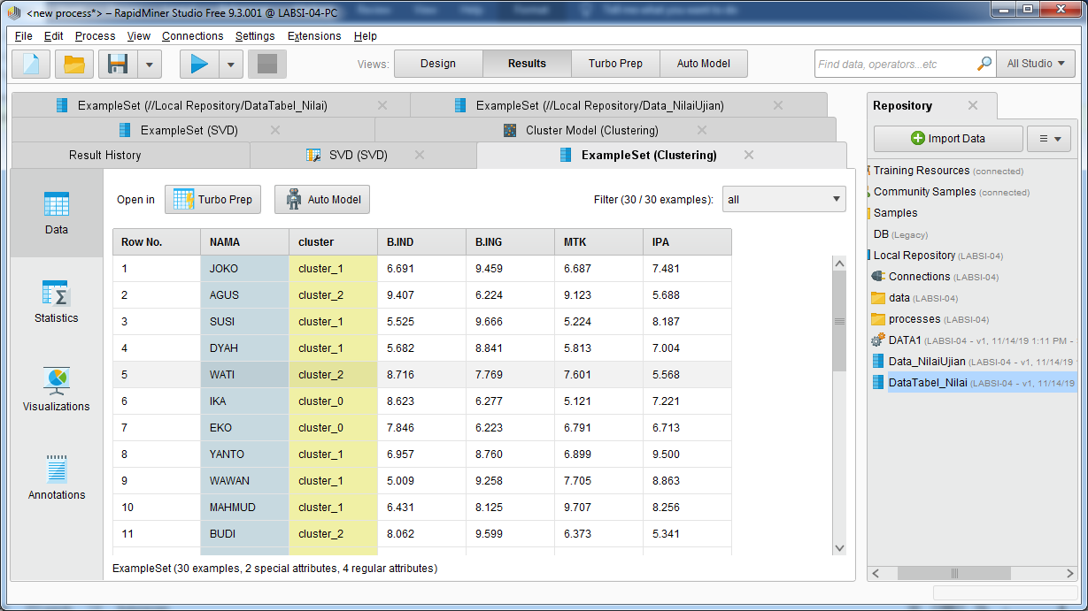

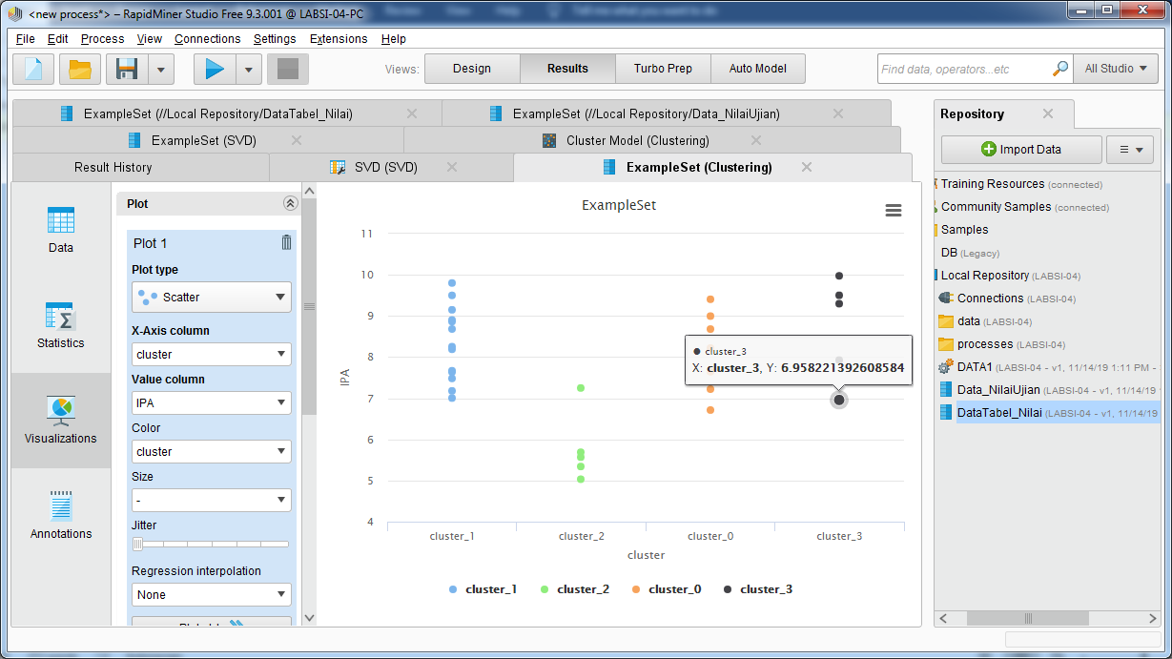

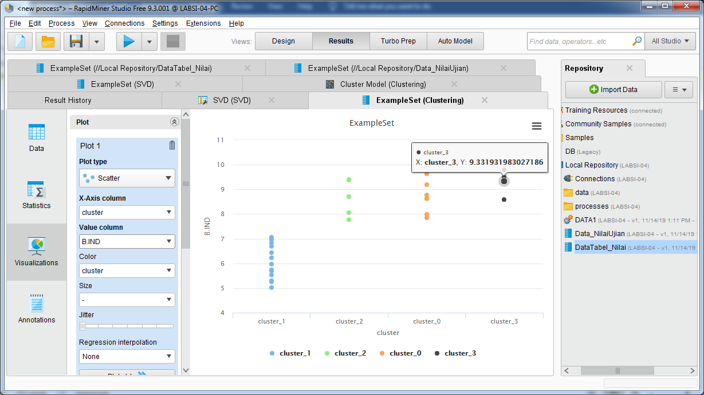

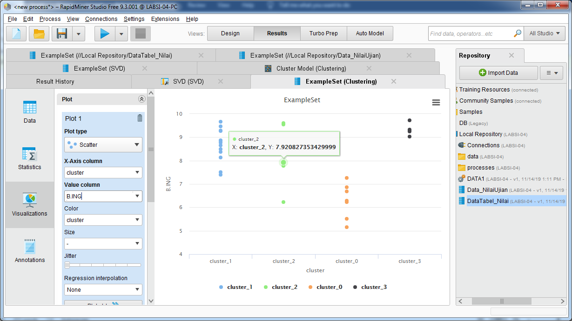

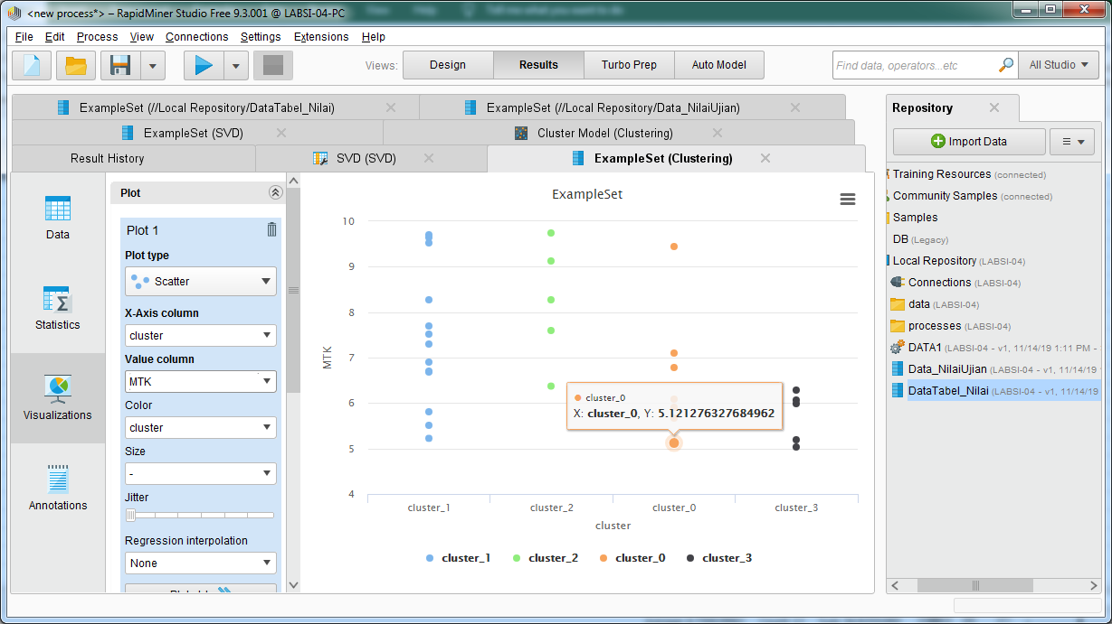

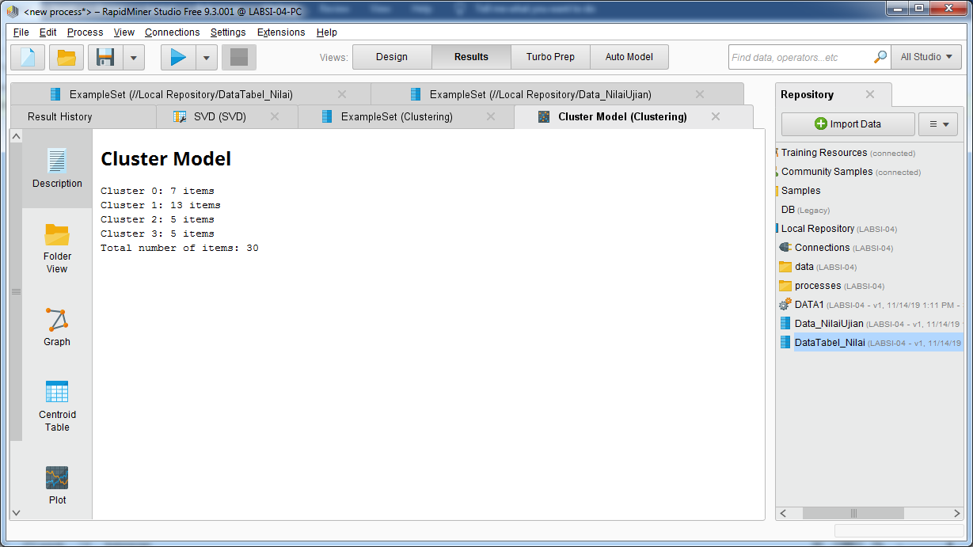

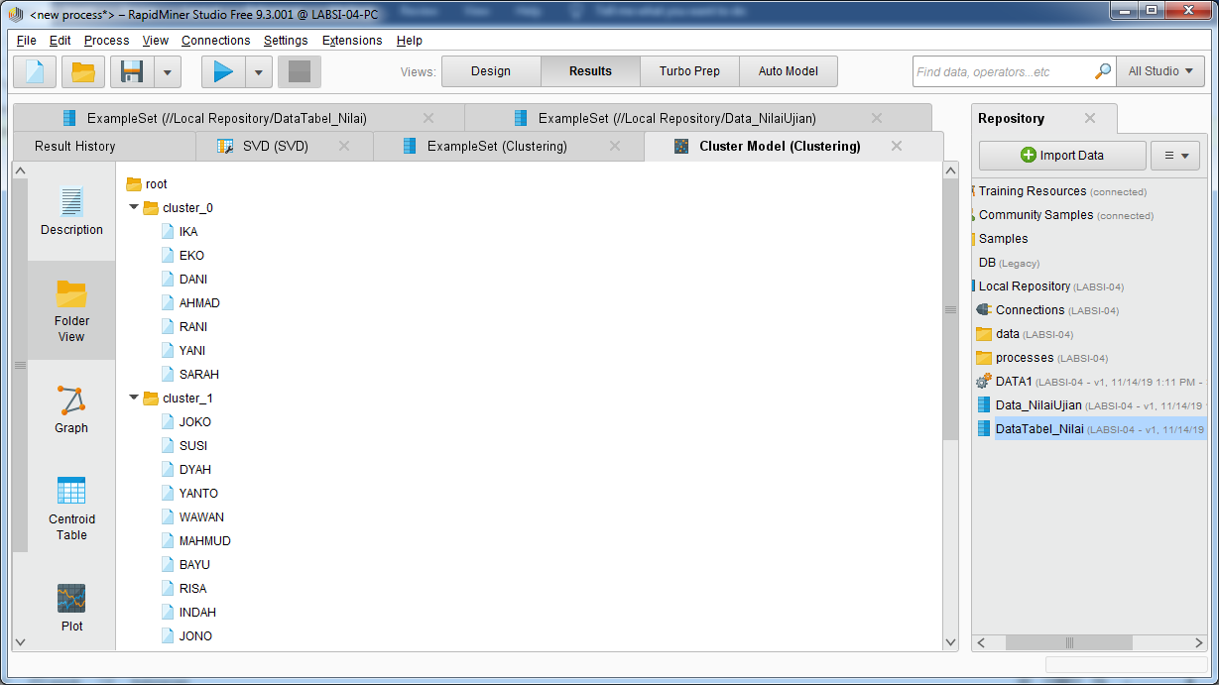

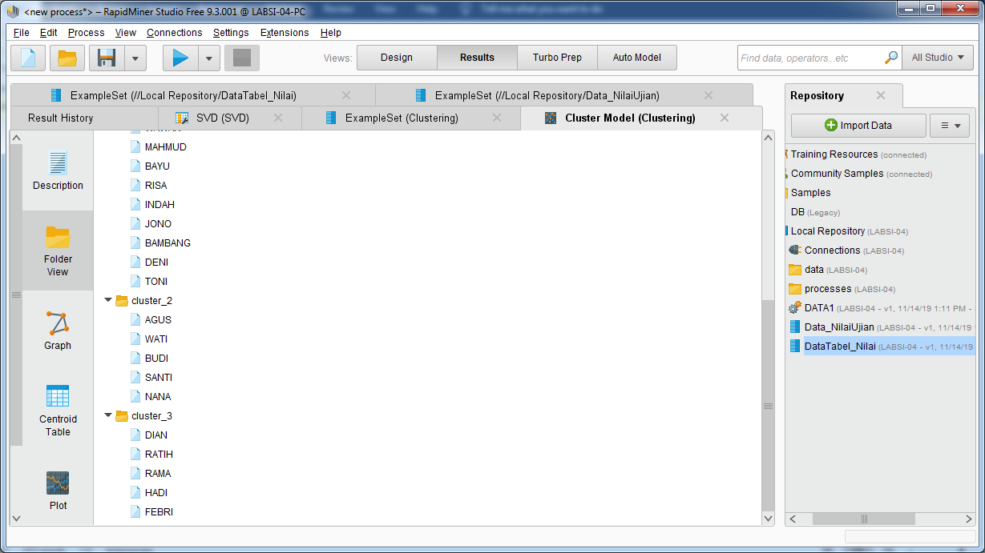

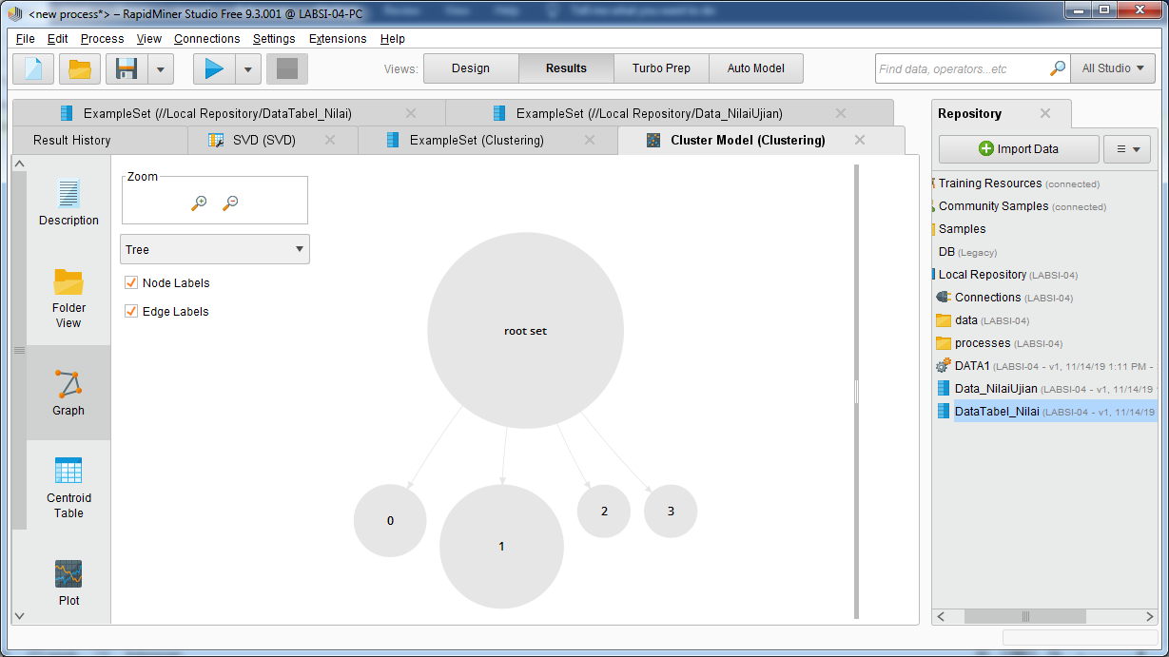

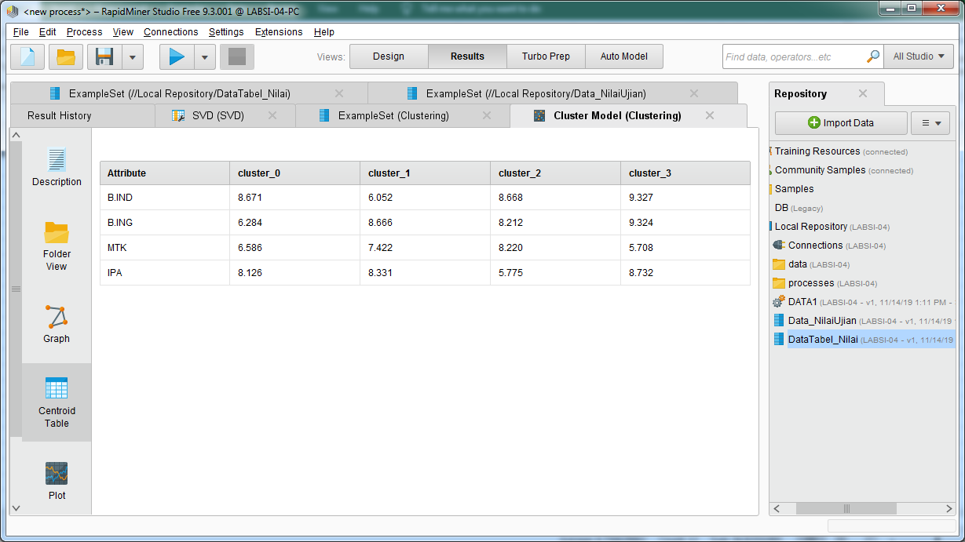

|  |  |  |  |  |  |  |  |
| --- | --- | --- | --- | --- | --- | --- | --- |
| **NO_SISWA** | **NAMA** | **B.IND** | **B.ING** | **MTK** | | **IPA** | **Claster** |
| S-106 | IKA | 8,45 | 7,54 | 8,34 | | 7,30 | 0 |
| S-107 | EKO | 7,79 | 7,17 | 9,08 | | 8,15 | 0 |
| S-114 | DANI | 9,29 | 5,37 | 7,02 | | 6,93 | 0 |
| S-115 | AHMAD | 8,83 | 8,47 | 6,88 | | 5,55 | 0 |
| S-118 | RANI | 6,92 | 8,72 | 9,02 | | 7,49 | 0 |
| S-119 | YANI | 9,87 | 5,16 | 8,14 | | 7,77 | 0 |
| S-123 | SARAH | 8,55 | 9,17 | 8,96 | | 8,09 | 0 |
|  |  |  |  |  | |  |  |
| S-101 | JOKO | 8,50 | 8,06 | | 9,64 | 8,72 | 1 |
| S-103 | SUSI | 5,78 | 6,84 | 6,41 | | 9,60 | 1 |
| S-104 | DYAH | 8,48 | 6,92 | 5,89 | | 5,90 | 1 |
| S-108 | YANTO | 7,52 | 5,55 | 7,44 | | 9,71 | 1 |
| `S-109 | 1 | 9,38 | 8,22 | 8,65 | | 7,89 | 1 |
| S-110 | MAHMUD | 5,91 | 6,42 | 7,31 | | 9,26 | 1 |
| S-116 | BAYU | 5,19 | 6,39 | 9,33 | | 7,55 | 1 |
| S-117 | RISA | 5,98 | 9,20 | 5,76 | | 6,35 | 1 |
| S-122 | JONO | 7,84 | 7,30 | 7,00 | | 5,40 | 1 |
| S-125 | BAMBANG | 5,67 | 5,89 | 5,23 | | 5,92 | 1 |
| S-129 | DENI | 8,48 | 5,88 | 5,71 | | 9,89 | 1 |
| S-130 | TONI | 5,17 | 6,08 | 9,68 | | 7,85 | 1 |
| S-102 | AGUS | 5,70 | 7,09 | 5,53 | | 8,62 | 2 |
| S-105 | WATI | 6,36 | 6,47 | 7,23 | | 8,70 | 2 |
| S-111 | BUDI | 5,30 | 6,07 | 7,52 | | 6,59 | 2 |
| S-112 | SANTI | 8,18 | 5,97 | 9,53 | | 7,21 | 2 |
| S-121 | INDAH | 6,82 | 5,23 | 5,04 | | 5,61 | 2 |
| S-127 | NANA | 5,75 | 6,19 | 6,35 | | 8,09 | 2 |
|  |  |  |  |  | |  |  |
|  |  |  |  |  | |  |  |
| S-113 | DIAN | 8,39 | 7,33 | 8,90 | | 5,53 | 3 |
| S-120 | RATIH | 7,99 | 8,39 | 7,65 | | 7,06 | 3 |
| S-124 | RAMA | 8,33 | 9,34 | 9,13 | | 9,86 | 3 |
| S-126 | HADI | 8,31 | 8,50 | 9,50 | | 8,15 | 3 |
| S-128 | FEBRI | 7,04 | 5,52 | 8,61 | | 5,70 | 3 |
|  |  |  |  |  | |  |  |
|  |  |  |  |  | |  |  |